Club Fígaro announces the names that will make up the professional jury of the Spanish Hairdressing Awards in its 12th edition.
Five reference names in Spanish and International Hairdressing sector, which will have the mission of evaluating the participating collections:

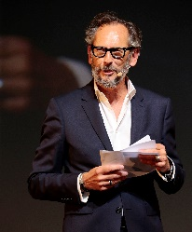
Mike Vincent (France), born in 1960 in Paris from a French father and an English mother, Mike Vincent began his career in the industry in 1987 after being graduated at a famous Business School and 5 years in advertising. After a short period of time spent at L'Eclaireur des Coiffeurs, Mike joined La Coiffure de Paris magazine in 1988, and as general manager spread the brand worldwide opening up to 22 licenses in Europe, North and South America and Asia. In 2002, he left the company and launched his own brand, TRIBU-TE, including both printed/digital publications and the famous TRIBU-TE SHOW in Paris and London. This coming September, Tribu-te will celebrate its 20th anniversary.

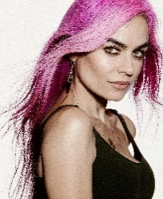
Beatriz Matallana (Spain) is one of the most versatile stylists in our country and for more than 40 editions she has been the hairdressing director of the Mercedes Benz Fashion Week Madrid. Her portfolio ranges from productions for magazines, advertisements and video clips to being the trusted makeup artist and hairdresser for celebrities such as Shakira, Elsa Pataky, Amaia Salamanca or Eugenia Silva.

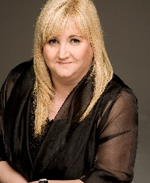
Maeve O’Healy-Harte (Ireland), founder & Editor of Irish Hairdresser Magazine since its inception in 1996 and founder of BEST of the BEST Irish & International Photographic Awards (1997), Maeve has been involved in the Hairdresser trade/profession for over 40 years. She was a Hair & Beauty business owner, hairdresser, trainer and competitor. She is a proud OMC Ambassador and Advisor and an ‘Officer’ of Intercoiffure and Europe Vice-President of A.I.P.P.

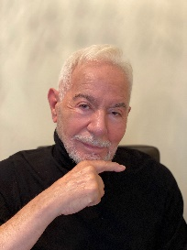
César Morales (Spain), is the first hairdresser named with the distinction of Doctor Honoris Causa of hairdressing. In 1985, he inaugurated the first high fashion school in Madrid. He collaborated with Pasarela Cibeles and the main fashion designers of the time. Vogue choose a picture in which he collaborated as a mythical image. In 1990, after having established in the national market, he decided to promote his professional career expanding internationally, taking the leap to the rest of Europe and Latin America. He has worked on sets and shows with Vidal Sassoon and Toni & Guy, to whom he is united by a great friendship.

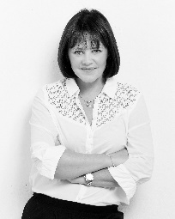
Sally Brooks (UK), is the current British Hairdresser of the Year, having previously won it in 2017 and 2018. As co-founder of Brooks & Brooks in London, Sally is one of the most exciting hairdressers of her generation, in regular demand for education, shows and seminars. She recently produced The Journey To My Destination, a 90-minute documentary about the opportunities the industry has to offer, taking it on a tour of schools and colleges to attract new talent to hairdressing.

